**Practical no. 1**

**Aim:** Create an HTML document with the following formatting options:

1. Bold

2. Italic

3. Underline

4. Heading (Using H1 to H6 Heading style)

5. font (Type, size and color)

6. Background (colored background /image background color)

7. Paragraph

8. Line break

9. Horizontal rule

10. Pre tag

**Coding:**

<html>

<head>

<title>Program No. 1</title>

<H1>Shivaji Science</H1>

<H2>Shivaji Science</H2>

<H3>Shivaji Science</H3>

<H4>Shivaji Science</H4>

<H5>Shivaji Science</H5>

<H6>Shivaji Science</H6>

<H7>Shivaji Science</H7>

</head>

<Body BGcolor="pink">

<P>BCA II year III sem<br>

</P>

<font size="16" color="red">

font formating bold</font>

<b>bold</b>

<i>italic</i>

<u>underline</u>

<pre>

web technology-1

</pre>

</body>

</html>

**Output:**

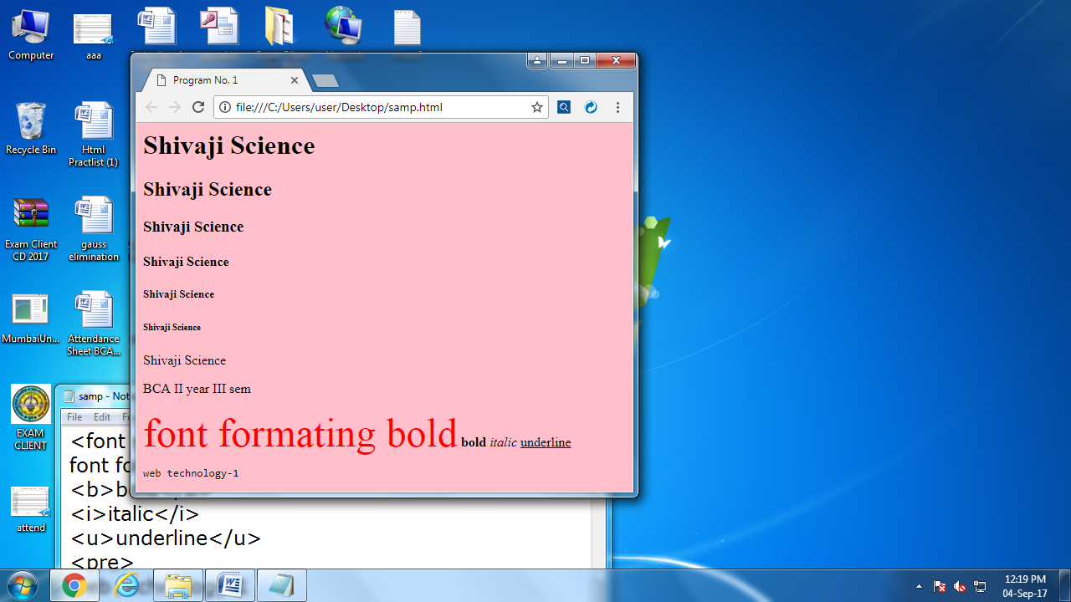

**Practical no. 2**

**Aim:** Create an HTML document which consists of:

1.Ordered list 3. Nested list

2.Unordered list 4. Image

**Coding:**

<html>

<head>

<title>PROGRAM 2</title>

</head>

<body>

<br><br><br><br>

<center>

<table cellspacing="16">

<tr>

<td>

<table border="1" align="left" cellspacing="15">

<tr>

<td>

<img src="C:\Users\Public\Pictures\Sample Pictures\Jellyfish.jpg"width="111" height"111">

<font size="16" style="Arail"><b>XYZ Ltds update </b></font>

<ol>

<li>Introduction

<li>company financial update

<ul>type="circle"

<li>first Quarter

<li>Second Quarter

<li>Third Quarter

<li>fourth Quarter

</ul>

<li>Advertising update

<ul type="circle">

<li>result of newspaper compaign

<li>Addition of staff

<li> new through on television

</ul>

<li>human resource update

</ol>

</td>

</tr>

</table>

<table border="1 cell padding="6"cellspacing"15">

<tr>

<td>

<ol type="A">

<li>safety consideration

<ol type="1">

<li>body substance isolation

<li>sense safty

<li>Intial sizeup

</ol>

<li>Initial pataient assessment

<ol type="1">

<li>genral impression

<li>unresponsiveness

<ol type="i">

<li>Alert to person,place and time

<li>varbal response to audible stimuli

<li>pain envokes verbal or physical respone

<li>unresponsiveness to stmuli

</ol>

</ol>

<li>paitien critical need

<ol type="1">

<li>Airway

<li>Breating

<ol type="1">

<li>use oxygen of indicated

<li>consider use of value mask

</ol>

<li>circulation

<li>Bleding

</ol>

</ol>

</table>

</table>

</body>

</html>

**Output:**

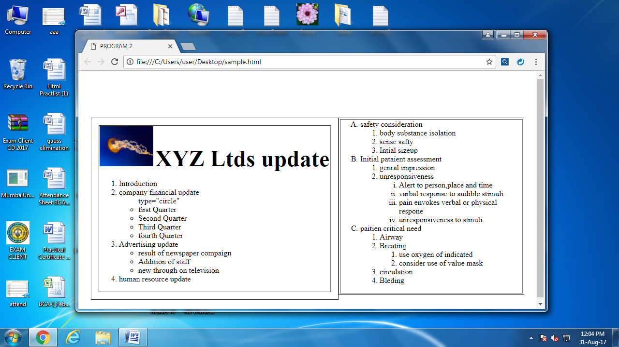

**Practical no. 3**

**Aim:** Create an HTML document which implements Internal Linking as well as External Linking:

**Coding:**

<html>

<head>

<title>program3</title>

</head>

<body>

<font size="80"<b>External Link</b></font>

<br>

<br>

<a href="https://www.google.co.in/=1 & espv=2"><font size="50"><b>Google</b></font></a>

<br>

<br>

<font size="80"><b>Internal Link</b></font>

<br>

<br>

<a href="C:\users\users2\Desktop\pro1.html"><font size="50"><b>Program1</b></font></a>

</body>

</html>

**Output:**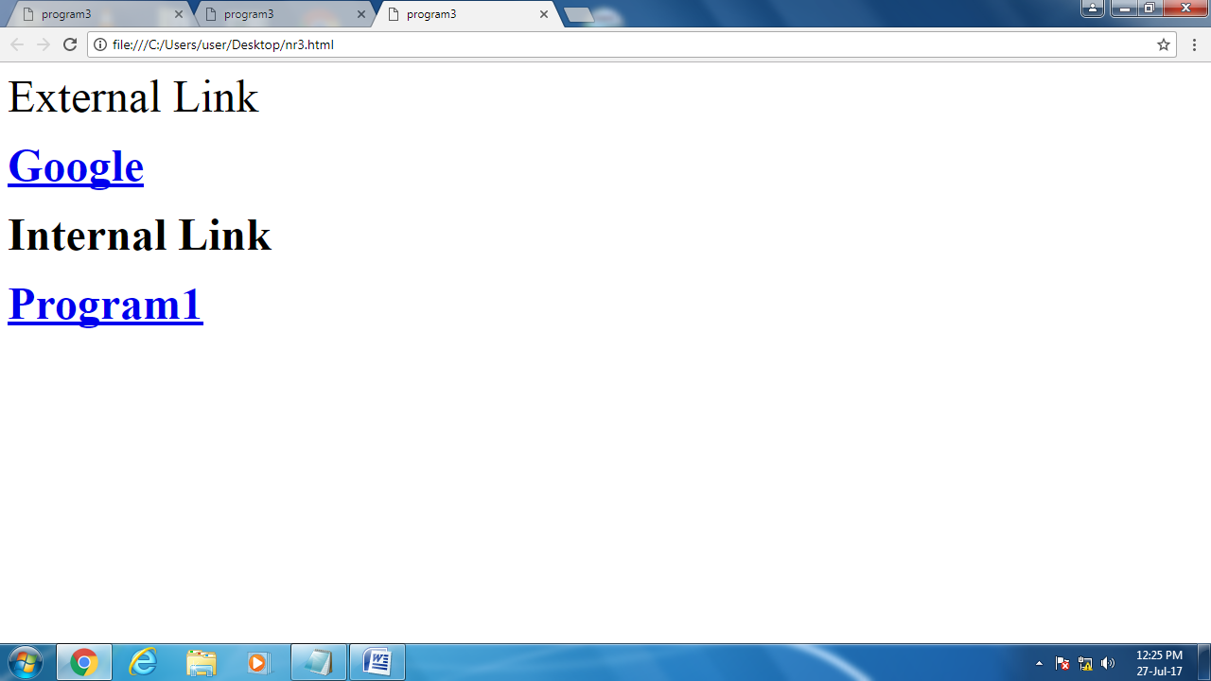

**Practical no. 4**

**Aim:** Create a table using HTML which consists of columns for Roll No., Student’s name and Grade**:**

**Coding:**

<html>

<head>

<title> Practical 4 <br> Create a Table using html</title>

</head>

<body>

<b></b>

<table border=1 witdh=400 height=250

align=center>

<th colspan="3"><b>RESULT</b></th>

<tr>

<td><b>Name</b></td>

<td><b>Roll no.</b></td>

<td><b>Grades</b></td>

</tr>

<tr>

<td>Rashmi</td>

<td>56</td>

<td>A+</td>

</tr>

<tr>

<td>Neha</td>

<td>57</td>

<td>B+</td>

</tr>

<tr>

<td>Ashvini</td>

<td>58</td>

<td>F-</td>

</tr>

</table>

</body>

</html>

**Output:**

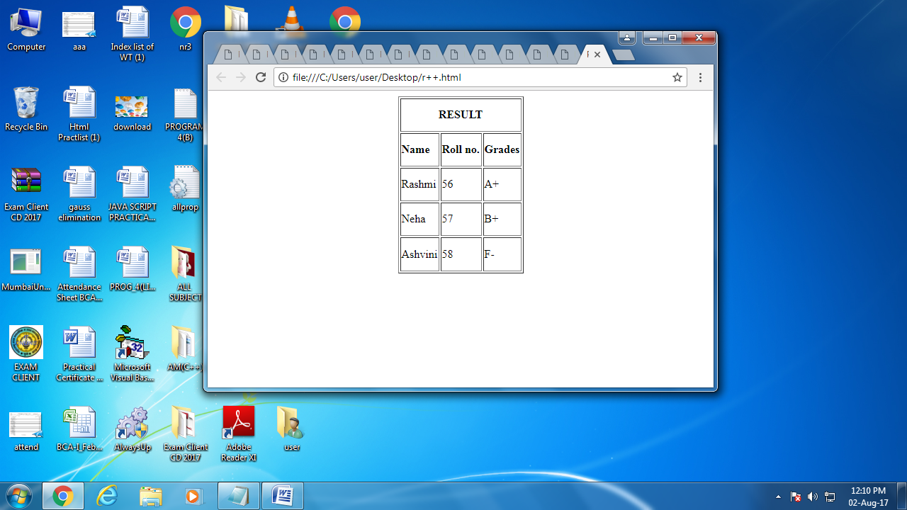

**Practical no. 5**

**Aim:** Write a program in HTML to create a table with a normal border, thick border, very thick border.

**Coding:**

<html>

<head>

<title> Practical 5 <br> Create a Table using html</title>

</head>

<body>

<h4>With a normal Border <h4>

<table border="1">

<tr>

<td>First</td>

<td>Row</td>

</tr>

<tr>

<td>second</td>

<td>Row</td>

</tr>

</table>

<h4>With a Thick Border <h4>

<table border="8">

<tr>

<td>First</td>

<td>Row</td>

</tr>

<tr>

<td>second</td>

<td>Row</td>

</tr>

</table>

<h4>With a very Thick Border <h4>

<table border="15">

<tr>

<td>First</td>

<td>Row</td>

</tr>

<tr>

<td>second</td>

<td>Row</td>

</table>

<h4>With a very very Thick Border <h4>

<table border="20">

<tr>

<td>First</td>

<td>Row</td>

</tr>

<tr>

<td>second</td>

<td>Row</td>

</tr>

</table>

</body>

</html>

**Output:**

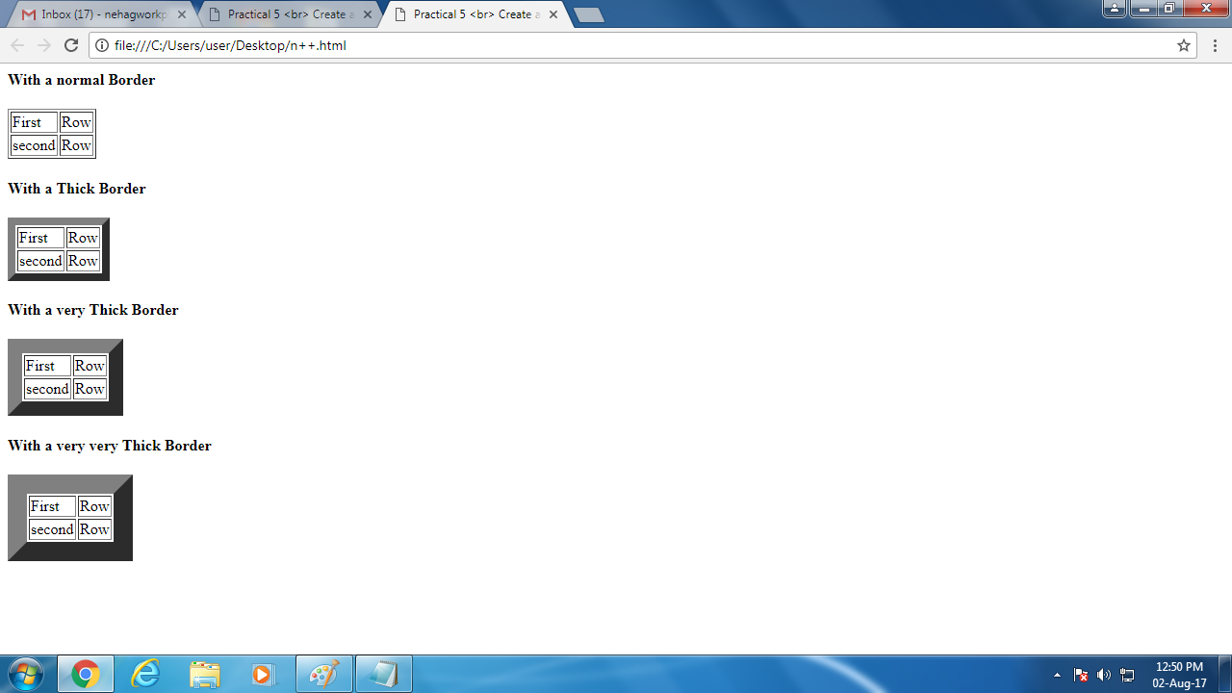

**Practical no. 6**

**Aim:** Create a form using HTML which has the following types of controls:

1. TextBox 3. Check Box

2. Option/Radio Button 4. Reset and Submit Button

**Coding:**

<html>

<head>

<title>program6</title>

</head>

<body>

<table align="center" border="3" width="1000" height="500">

<tr>

<td>

<h2>SUBSCRIBE TO XYZ NEWS MAGAZINE AND E-MAILS</H2>

<h4><p>Interested in receiving daily small updates of all latest news ? Well, now you can. And best of all, it is FREE! Just fill out this form and submit it by clicking the "send it in" button. We wil put you on our mailing list and you will receive your first E-mail in 3-5 days </h4></p>

<hr>

<p>Please fill in the following boxes to help us send the emails and our newsletter. </p>

<form action="Newsletter Form.php" action="Newsletter Form.php" >

First Name<input type="text" Name="First Name "value="">

<br>

<br>

Last Name<input type="text"Name="Last Name "value"">

<br>

<br> Business<input type="text"

Name="Business" value="">

<br>

<br>

<p>We must have a correct E-mail Address to send you the newsletter</p>E-mail<input type="">

<p>How did you hear about XYZ news magazines and E-mails</p>

<input type="radio" name="optionlist" value="here on the Web "checked>Here on the Web

<input type="radio"name="optionlist" value="Television">Magazine

<input type="radio"name="optionlist" value="Television">Television

<input type="radio" name="optionlist" value="Other">Other

<p>Would you like to be on your regular mailing list</p>

<input type="checkbox" name"" value="Yes we like junk mails"checked>yes we like mails

<br>

<br>

<input type="reset"value ="reset">

<input type="button"

Onclick="alert('Submitted!')"value="send it in">

</td>

</tr>

<hr>

</form>

</table>

</body>

**Output:**

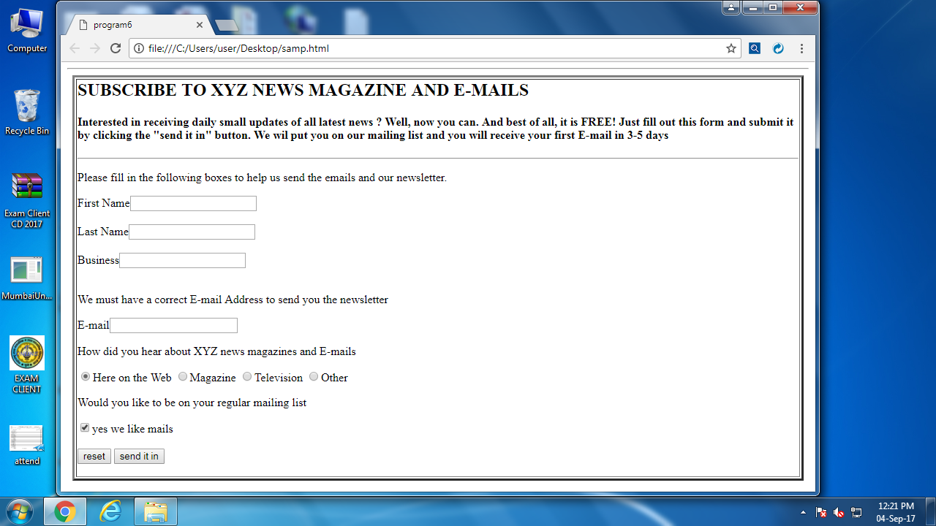

**Practical no. 7**

**Aim:** Create HTML document (having multiple frames) in the given three formats:

**Coding: (i)**

<html>

<head>

<title>Program 7</title>

</head>

<frameset rows="30%,30%,40%">

<frame src="C:\Users\Administrator\Desktop/rani.jpg">

<frame src="C:\Users\Administrator\Desktop/2.jpg">

<frame src="C:\Users\Administrator\Desktop/shivaji.jpg">

</frameset>

</html>

**Output:**

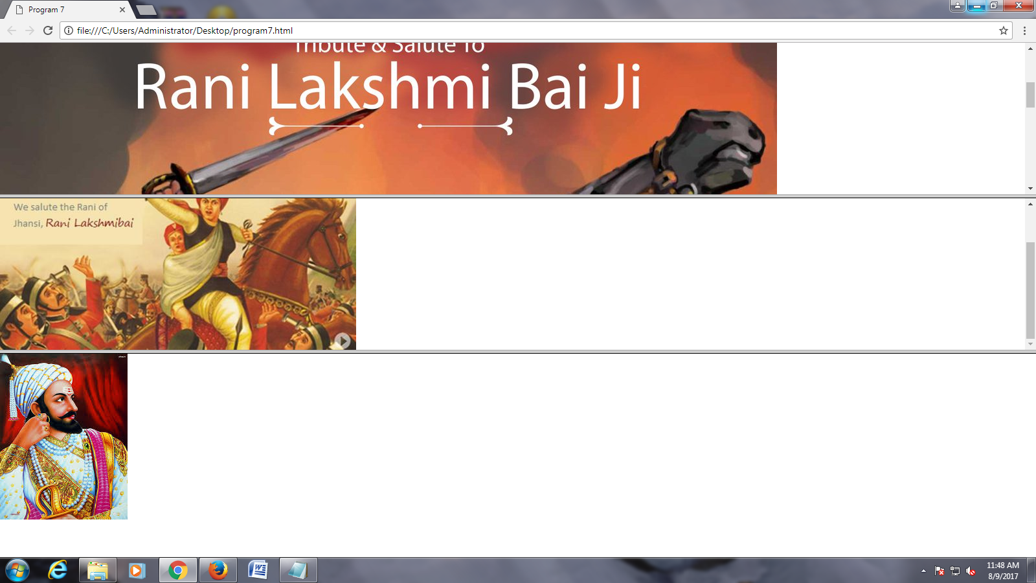

**Coding: (ii)**

<html>

<head>

<title>Program 7</title>

</head>

<frameset rows="30%,*">

<frame src="C:\Users\Administrator\Desktop/rani.jpg">

<frameset cols="34%,35%">

<frame src="C:\Users\Administrator\Desktop/2.jpg">

<frame src="C:\Users\Administrator\Desktop/shivaji.jpg">

</frameset>

</html>

**Output:**

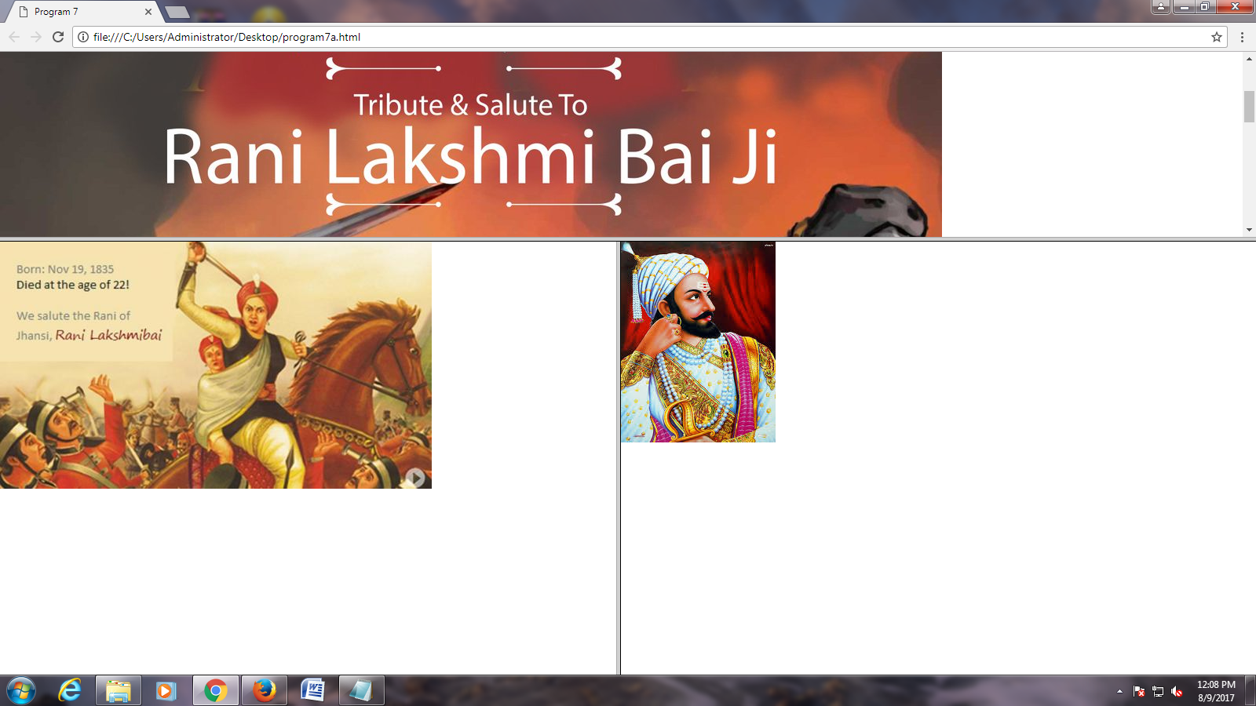

**Practical no. 8**

**Aim:** Write an HTML program to create a Frameset Border , Box, Void, Above, Below, Hside, Vside, LHS, RHS

**Coding:**

<html>

<body>

<p>

If you see no frame around the tables in these examples, your is too old, or does not support it.

</p>

<h4>with frame="border":</h4>

<table frame="border">

<tr>

<td>First</td>

<td>Row</td>

</tr>

<tr>

<td>Second</td>

<td>Row</td>

</tr>

</table>

<h4>with frame="box":</h4>

<table frame="box">

<tr>

<td>First</td>

<td>Row</td>

</tr>

<tr>

<td>Second</td>

<td>Row</td>

</tr>

</table>

<h4>with frame="void":</h4>

<table frame="void">

<tr>

<td>First</td>

<td>Row</td>

</tr>

<tr>

<td>Second</td>

<td>Row</td>

</tr>

</table>

<h4>with frame="above":</h4>

<table frame="above">

<tr>

<td>First</td>

<td>Row</td>

</tr>

<tr>

<td>Second</td>

<td>Row</td>

</tr>

</table>

<h4>with frame="below":</h4>

<table frame="below">

<tr>

<td>First</td>

<td>Row</td>

</tr>

<tr>

<td>Second</td>

<td>Row</td>

</tr>

</table>

<h4>with frame="Hsides":</h4>

<table frame="Hsides">

<tr>

<td>First</td>

<td>Row</td>

</tr>

<tr>

<td>Second</td>

<td>Row</td>

</tr>

</table>

<h4>with frame="Vsides":</h4>

<table frame="Vsides">

<tr>

<td>First</td>

<td>Row</td>

</tr>

<tr>

<td>Second</td>

<td>Row</td>

</tr>

</table>

<h4>with frame="lhs":</h4>

<table frame="lhs">

<tr>

<td>First</td>

<td>Row</td>

</tr>

<tr>

<td>Second</td>

<td>Row</td>

</tr>

</table>

<h4>with frame="rhs":</h4>

<table frame="rhs">

<tr>

<td>First</td>

<td>Row</td>

</tr>

<tr>

<td>Second</td>

<td>Row</td>

</tr>

</table>

</body>

</html>

**Output:**

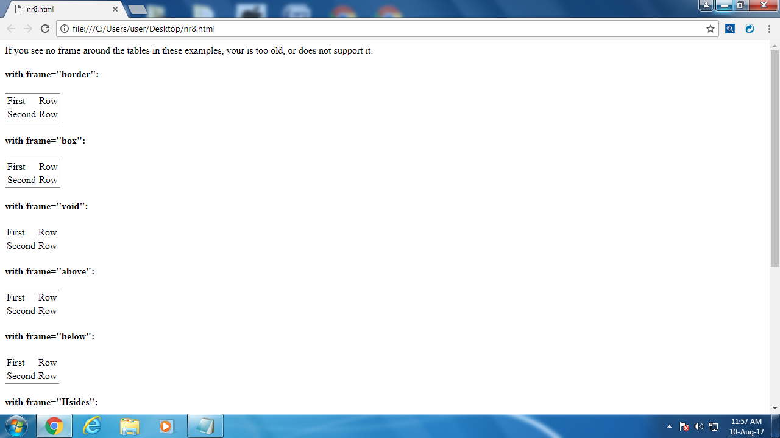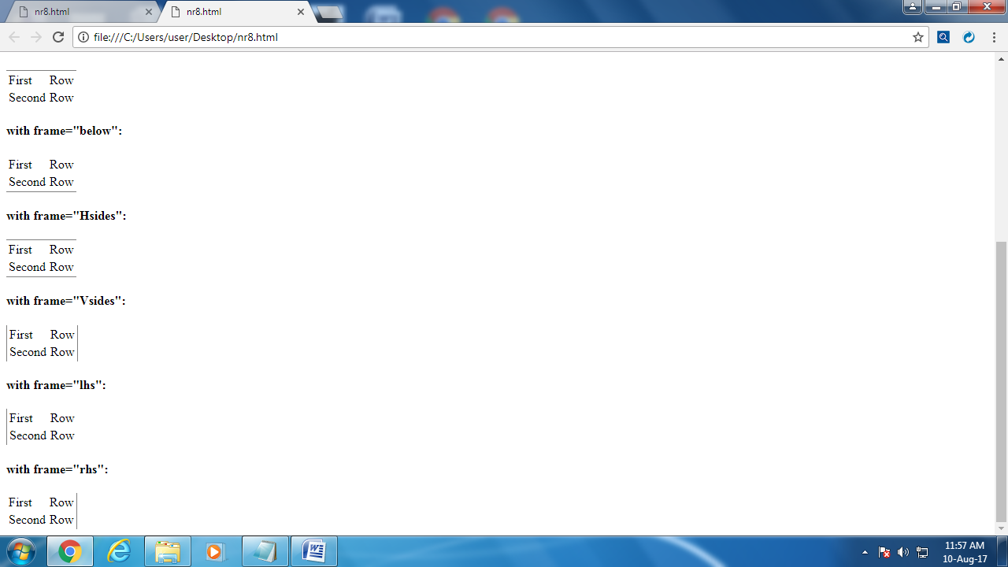

**Practical no. 9**

**Aim:** Write a program to create in an HTML for student identification.

**Coding:**

<html>

<head>

<Title>Example 9</title>

</head>

<body bgcolor="pink">

<H1 Align="center">

<font color="red"> PERSONAL

INFORMATION</font><h1>

<H5>Student Identification<H5>

First Name<input type="text" Name="First Name

"value="">

<br>

<BR>

Last Name<input type="text"Name="Last Name

"value"">

<br>

<BR>

<B>MY ADDRESS IS<B>:<textarea

NAME=ADDRESS, Rows=4>

</textarea><BR>

<BR>

pin:440018<br>

<I>MOBILE NO:98597439,89837986</font>

<HR>

DATE OF BIRTH:30/07/17<BR>

<p>Gender</p>

<input type="radio" name="optionlist"

value="female">female

<input type="radio"name="optionlist"

value="male">male<br>

<I>SEE YOU AGAIN </I>

<HR>

<CENTER>visit to <A

HREF="http://www.india.com">

india</A> </CENTER>

</body>

</html>

**Output:**

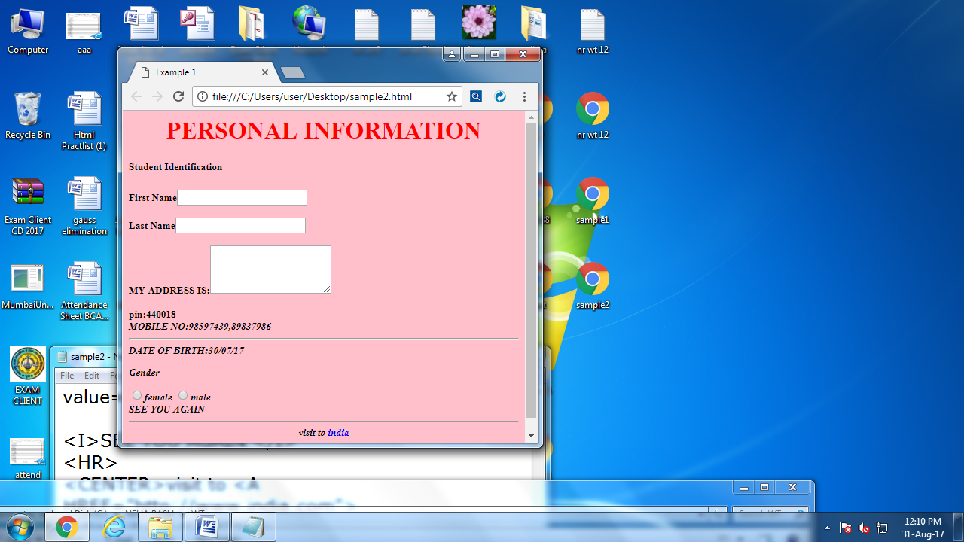\

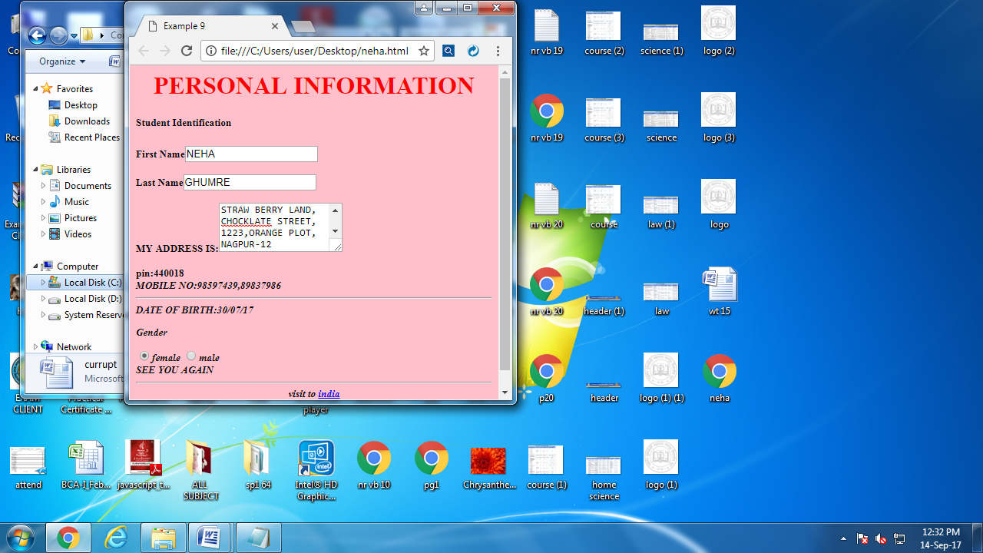

**Practical no. 10**

**Aim:** Write a program to demonstrate the course in RTM Nagpur university through UGC and AICTE

**Coding:**

<html>

<head>

<title>Program no10</title>

<style>

body

{

background-image:url("logo.png");

}

ul

{

list-style-type: none;

margin: 0;

padding: 0;

}

li a

{

display: block;

width: 60px;

background-color: #dddddd;

}

li a:hover

{

background-color: #555;

color: black;

}

.dropdown-content a

{

color: black;

padding: 12px 16px;

text-decoration: none;

display: block;

text-align: left;

}

.dropdown-content a:hover

{ background-color: #f1f1f1}

.Courses:hover .dropdown-content

{

display: block;

}

.dropdown-content {

display: none;

position: absolute;

background-color: #f9f9f9;

min-width: 160px;

box-shadow: 0px 8px 16px 0px rgba(0,0,0,0.2);

}

li {

float: left;

}

li a, .dropbtn {

display: inline-block;

color: white;

text-align: center;

padding: 14px 16px;

text-decoration: none;

}

li a:hover, .Courses:hover .dropbtn {

background-color: red;

}

li.Courses {

display: inline-block;

color:black;

align:center;

}

</style>

<body>

<div id="header">

<marquee><img src="header.png" width="50%">

</marquee>

</div>

<div id="nav">

<ul>

<li class="Courses" >

<a href="#" class="dropbtn">Courses</a>

<div class="dropdown-content">

<a href="#">Faculty of Arts and Social Science</a>

<img src="course.png">

<br><br>

<a href="#">Faculty of Science</a>

<img src="science.png">

<a href="#">Faculty of Law</a>

<img src="law.png">

<a href="#">Faculty of Education</a>

<img src="edu.png">

</div>

</li>

</ul>

</body>

</head>

</html>

**Output:**

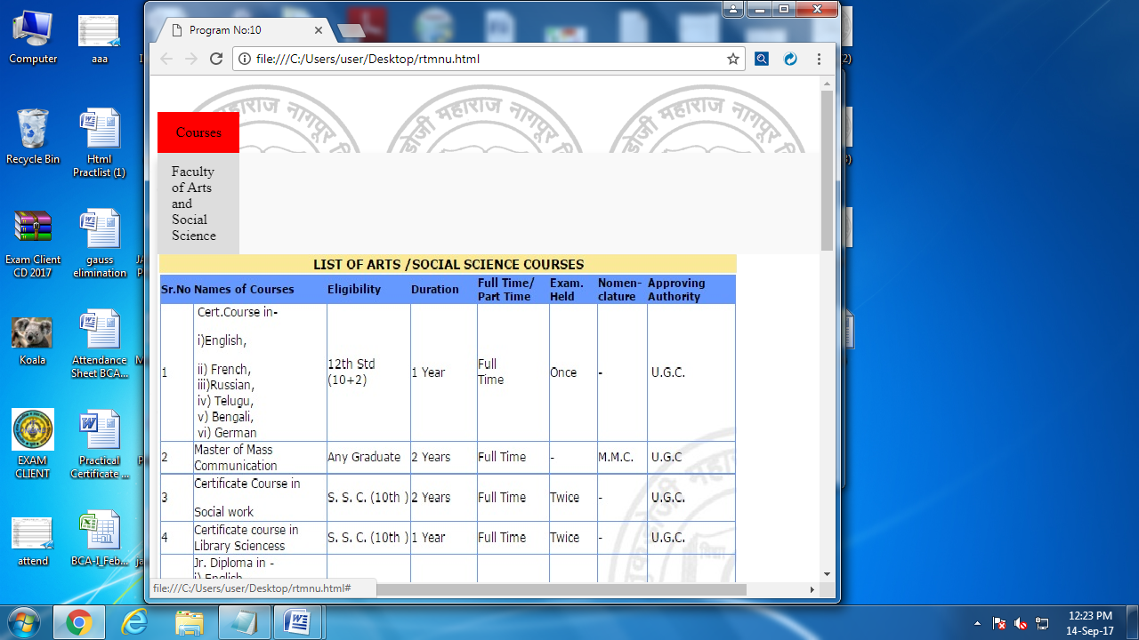

**Practical no. 11**

**Aim:** Write a program to demonstrate a physical style.

**Coding:**

<html>

<head>

<title>Program No. 11</title>

</head>

<h4>Physical style</h4>

<Body BGcolor="pink">

<b>The text will be Bold</b><br>

<i>The text will be Italic</i><br>

<u>The text will be Underline</u><br>

<STRIKE>The text will be strikeout</STRIKE><BR>

<BIG>The text will be in big size</BIG><BR>

<SMALL>The text will be in small size</SMALL><BR>

Subscript text: H<SUB>2</SUB>O<BR>

superscript text:M<SUP>2</SUP>4<BR>

</body>

</html>

**Output:**

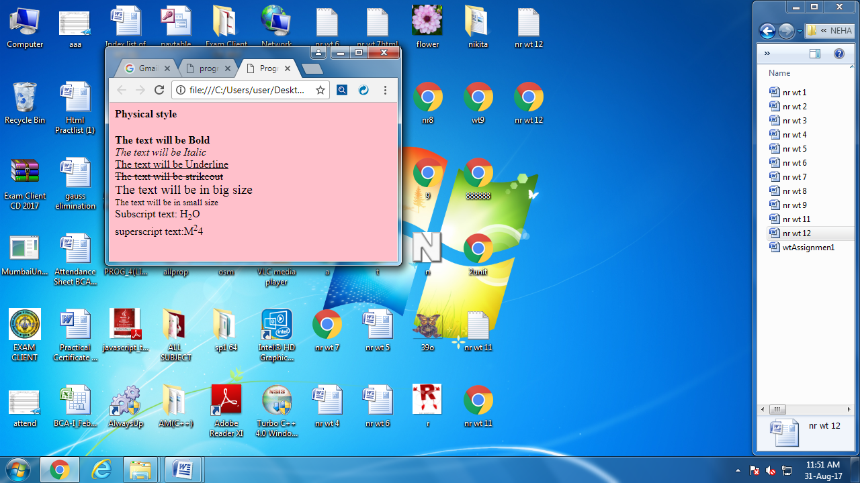

**Practical no. 12**

**Aim:** Write a program to demonstrate a logical style

**Coding:**

<html>

<head>

<TITLE>program 12</TITLE>

<Body>

<h4>logical style</h4>

<EM>Italic</EM><BR>

Area of traingle:<DFN>product of half,base and vertical height </DFN><BR>

Formula of area of a triangle=<code> ½ × b × h</code><BR>

<SAMP>Current status</SAMP><BR>

b = <var>base</var><BR>

h = <var>vertical height</var><BR>

</Body>

</html>

**Output:**

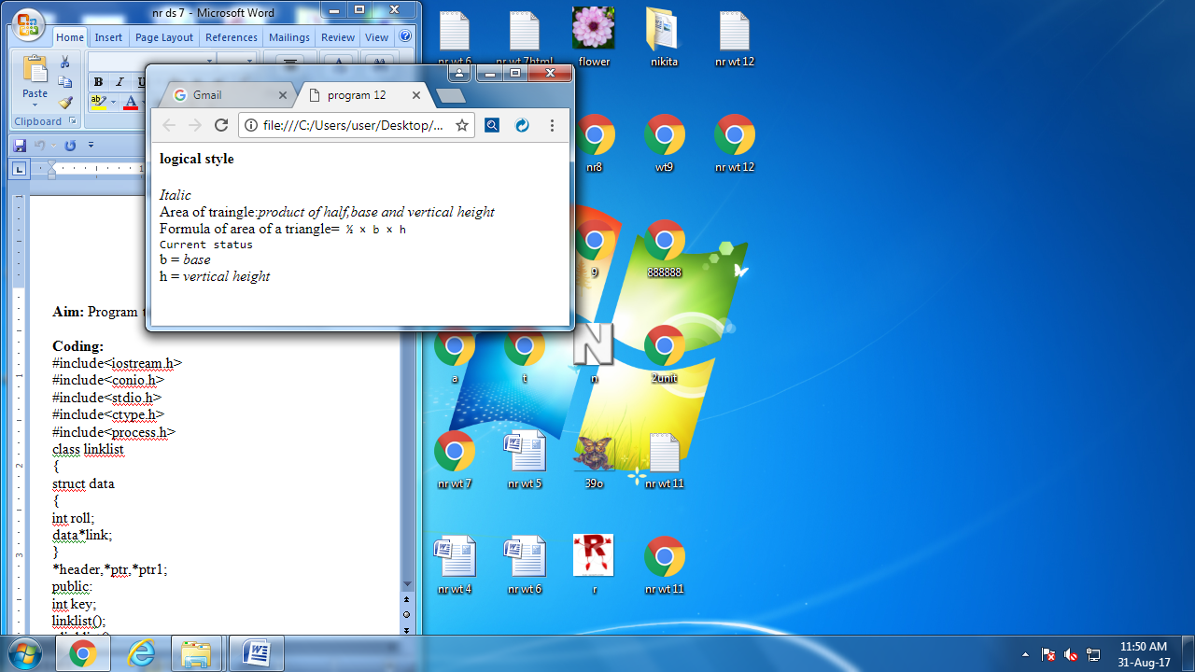

**Practical no. 13**

**Aim:** Write Html code to create following Output Using ordered list.

**Coding:**

<html>

<head>

<title>PROGRAM 13</title>

</head>

<body>

<ol type="A">

<li>India

<li>Maharashtra

<li>Madhyapradesh

<li>Uttarpradesh

<li>Punjab

</ol>

</body>

</html>

**Output:**

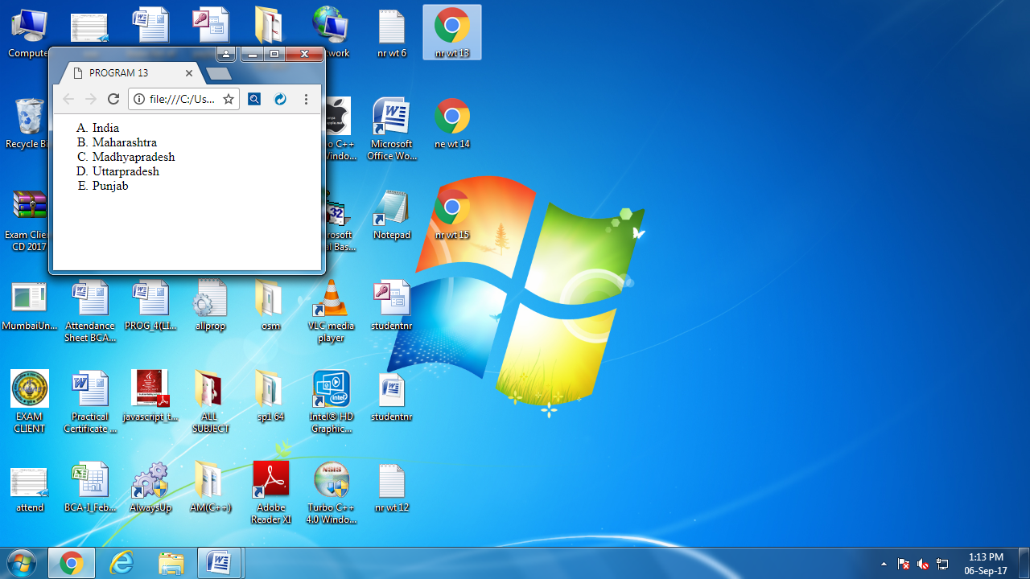

**Practical no. 14**

**Aim:** Write Html code to create following Output Using unordered list.

**Coding:**

**<**html>

<head>

<title>PROGRAM 14</title>

</head>

<body>

<table align="center" cellspacing="10" cellspadding="10">

<tr>

<td><b>Maharashtra

<td><b>Madhyapradesh

<td><b>Uttarpradesh</b>

</tr>

<tr>

<td><ul type="disc">

<li>Nagpur

<li>Wardha

<li>Mumbai

<li>Amravati

</ol>

</td>

<td><ul type="circle">

<li>Bhopal

<li>Indor

<li>Ujjain

</ol>

</td>

<td><ul type="square">

<li>Kanpur

<li>Azamgad

<li>Haridwar

</ol>

</td>

</tr>

</table>

</body>

</html>

**Output:**

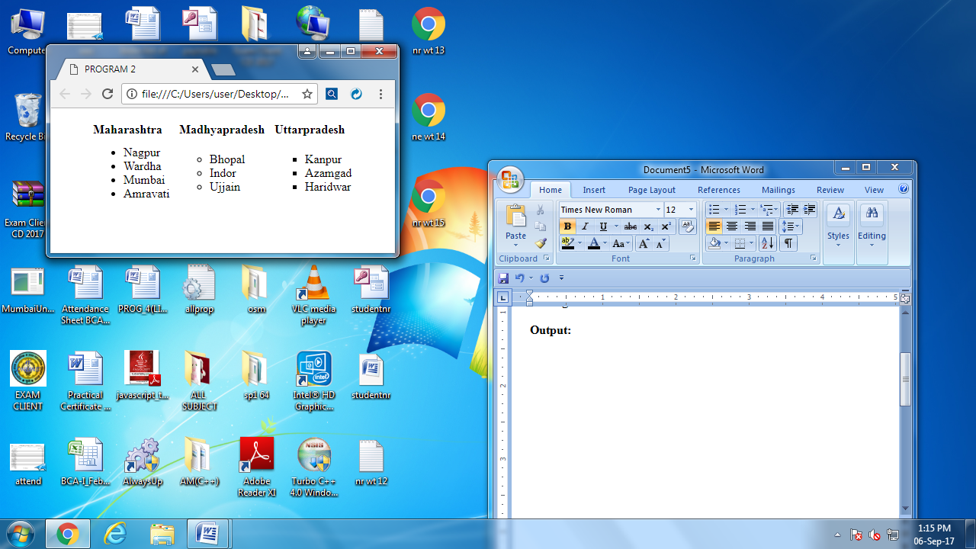

**Practical no. 15**

**Aim**: Write html code to crate following output by using definition list.

**Coding:**

<html>

<head>

<title>PROGRAM 15</title>

</head>

<body>

<dl>

<lh><b><u>Computer Science</b></u></lh>

<br>

<dt>C++</dt>

<dd><p>C++ is a general-purpose programming language. It has imperative, object-oriented and generic programming features, while also providing facilities for low-level memory manipulation.

It was designed with a bias toward system programming and embedded, resource-constrained and large systems, with performance, efficiency and flexibility of use as its design highlights.</p></dd>

<dt>DBMS</dt>

<dd><p>A database management system is simply a system that allows for users and applications to manage the use of data. This entails the updating, retrieving, and creating of data. Database management systems are some of the most widely used and essential systems in computing.</p></dd>

<dt>IT</dt>

<dd><p> Information technology management (IT management) is the process whereby all resources related to information technology are managed according to an organization's priorities and needs. This includes tangible resources like networking hardware, computers and people, as well as intangible resources like software and data. </p></dd>

<d1>

<br>

<br>

<d1>

<lh><b><u>Commerce</b></u></lh>

<br>

<dt>Account</dt>

<dd><p>

ccounting is often called the language of business. Companies implement accounting policies and procedures to accurately record its financial information. Small business owners may double as the bookkeeper until their business grows large enough to employ an accountant.</p></dd>

<dt>Statistics</dt>

<dd><p>statistics is the application of mathematics to statistics, which was originally conceived as the science of the state — the collection and analysis of facts about a country: its economy, land, military, population, and so on. Mathematical techniques which are used for this include mathematical analysis, linear algebra, stochastic analysis, differential equations, and measure-theoretic probability theory</p></dd>

<dt>Economics</dt>

<dd><p>economics or the economics of information is a branch of microeconomic theory that studies how information and information systems affect an economy and economic decisions. Information has special characteristics: It is easy to create but hard to trust. It is easy to spread but hard to control. It influences many decisions. </p></dd>

</d1>

</body>

</html>

**Output:**

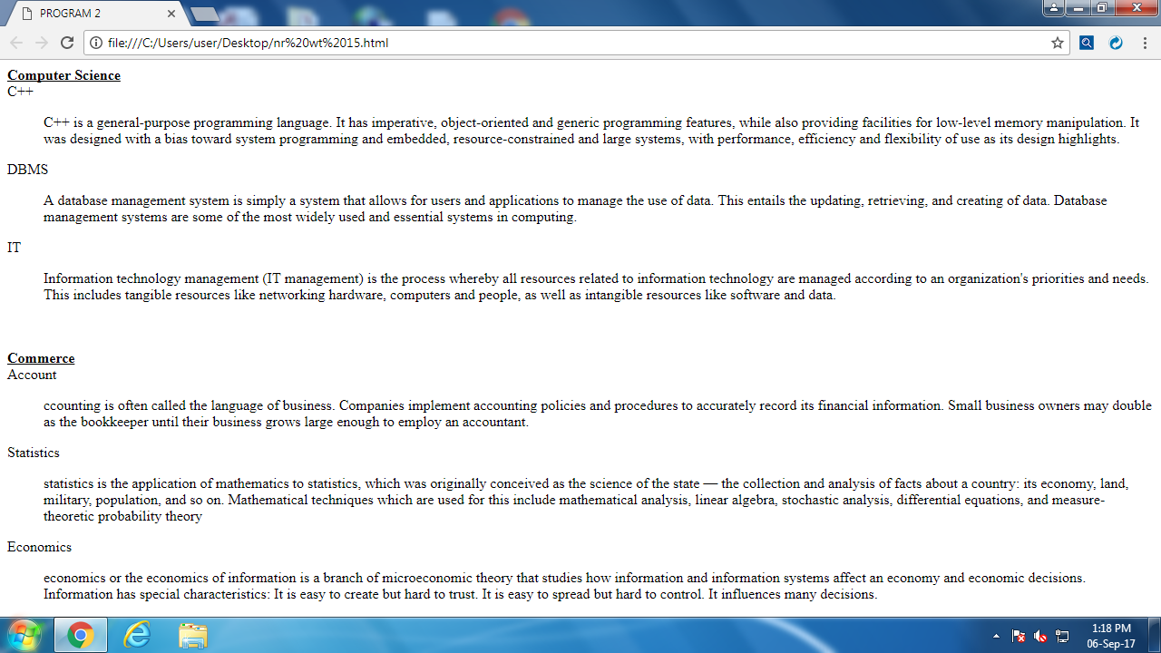

**Practical no.16**

**Aim:** Write a program to show simple email linking.

**Coding:**

<html>

<head>

<title>program16</title>

</head>

<body>

<font size="80"<b>Send Mail By</b></font>

<br>

<br>

<a href="https://accounts.google.com/ServiceLogin/signinchooser?service=mail&passive=true&

rm=false&continue=https%3A%2F%2Fmail.google.com%2Fmail%2F&ss=1&scc=1&ltmpl=default&ltmplcache=2&emr=1&osid=1&flowName=GlifWebSignIn&flowEntry=ServiceLogin"><font size="50"><b>Gmail</b></font></a>

<br>

<br>

<a href="https://in.yahoo.com/?p=us"><font size="50"><b>Yahoo</b></font></a>

</body>

</html>

**Output:**

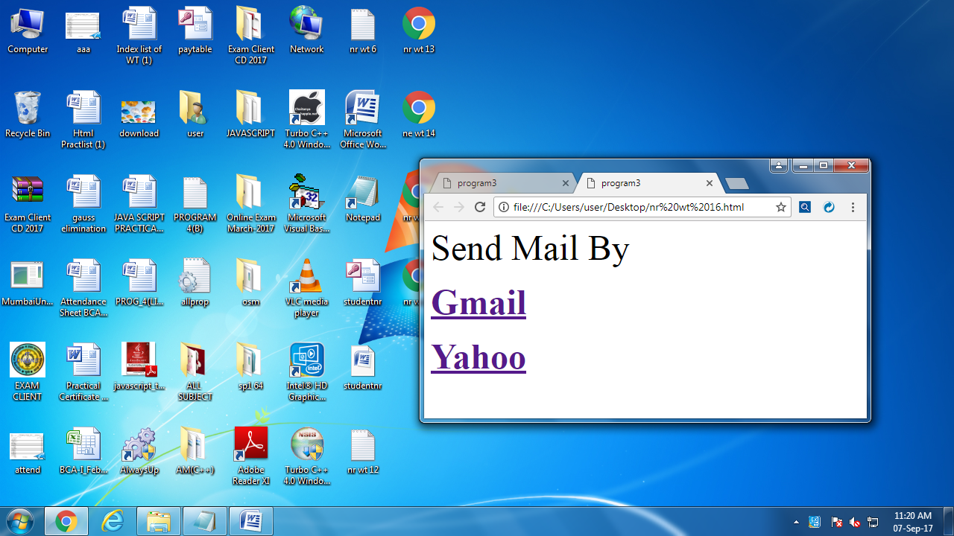

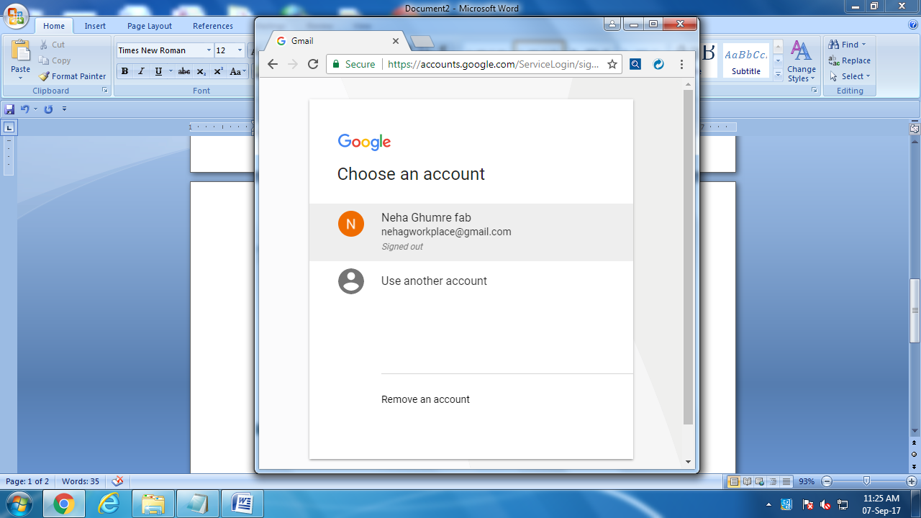

**Practical no. 17**

**Aim: Write an HTML code**

Page 1: a) Containing background image.

b) Hyperlink to page 2 by using text as a link.

c) Display the image and heading to image.

Page 2: a) Containing background image.

b) Hyperlink to page 1 by using image as a link.

c) Display the image and heading to image.

**Coding:**

**i)**

<html>

<head>

<title>program 17</title>

</head>

<body>

<font size="80"<b>Welcome to Page 1</b></font>

<body style="background-image:url(color.png)">

<br>

<a href="C:\Users\user\Desktop\pg2.html"><font size="50"><b>Page 2</b></font></a>

<br>

<br>

<img src="C:\Users\Public\Pictures\Sample Pictures\Jellyfish.jpg"width="111" height"111">

<br>

</body>

</html>

**ii)**

<html>

<head>

<title>program 17</title>

</head>

<body>

<font size="80"<b>Welcome to Page 2</b></font>

<body style="background-image:url(tulips.jpg)">

<br>

<font size="50"><b>Page 1</b></font></a>

<br>

<br>

<a href="C:\Users\user\Desktop\pg1.html" ><img src="C:\Users\Public\Pictures\Sample Pictures\Koala.jpg"width="111" height"111">

<br>

</body>

</html>

**Output:**

**i)**

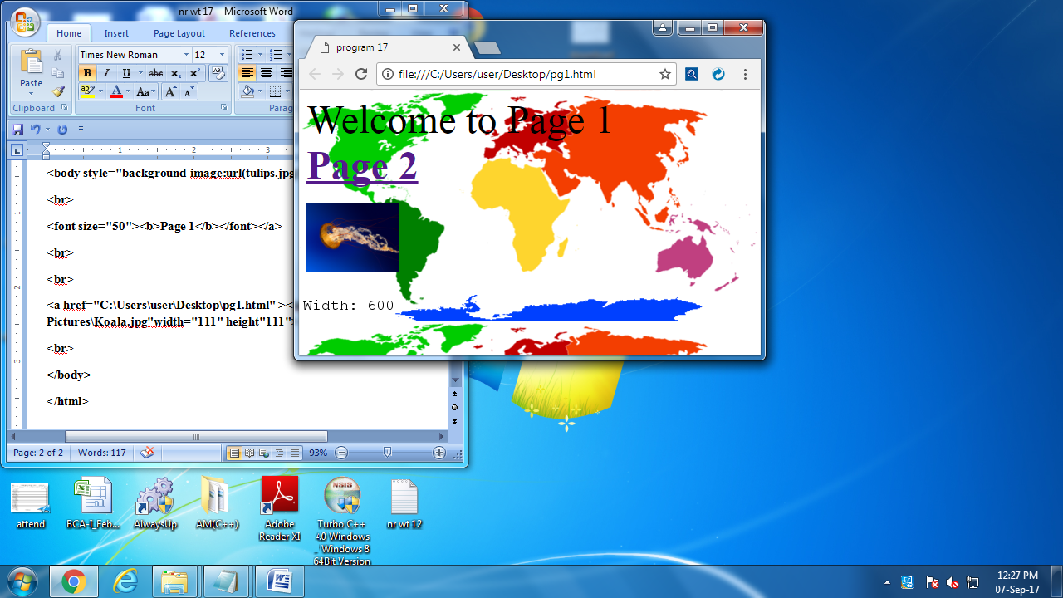

**ii)**

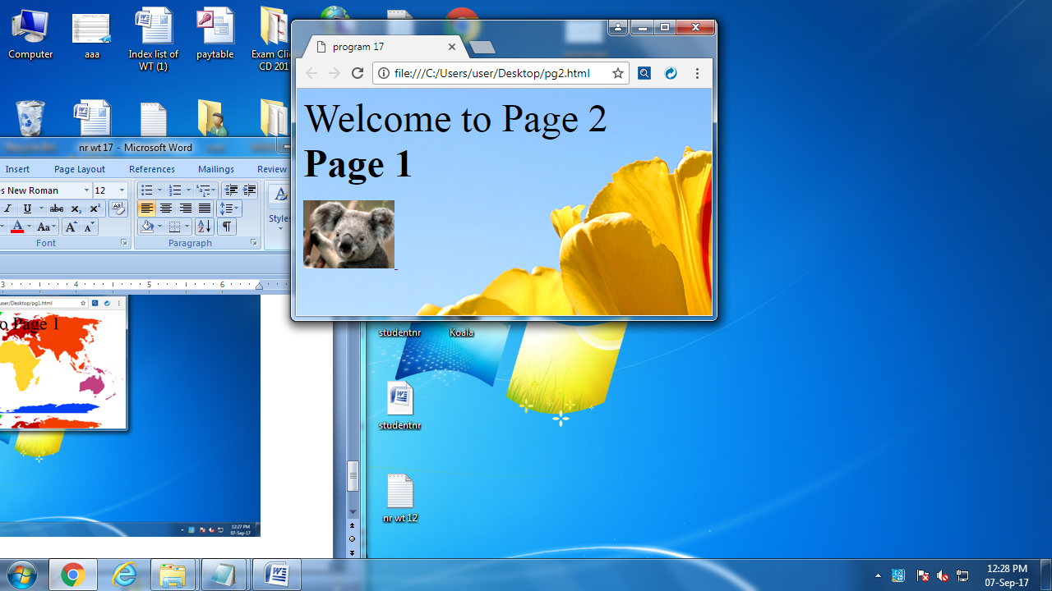

**Practical no. 18**

**Aim:** Write a program to creating frameset.

**Coding:**

<html>

<head>

<title>Program No. 18</title>

</head>

<frameset rows="20%,*,20%">

<frame src="C:\Users\user\Desktop\Chrysanthemum.jpg" height="100" weidth=""/>

<frameset cols="30%,*,40%">

<frame src="C:\Users\user\Desktop\Chrysanthemum.jpg" name="left" id="left"/>

<frame src="C:\Users\user\Desktop\Chrysanthemum.jpg" name="home" id="home"/>

<frame src="C:\Users\user\Desktop\Chrysanthemum.jpg" name="right" id="right"/>

</frameset>

<frame src="C:\Users\user\Desktop\Chrysanthemum.jpg" name="bottom" id="bottom"/>

<noframes>

<body>

<p><a href="menu.html">contents</a></p>

</body>

</noframes>

</frameset>

</html>

**Output:**

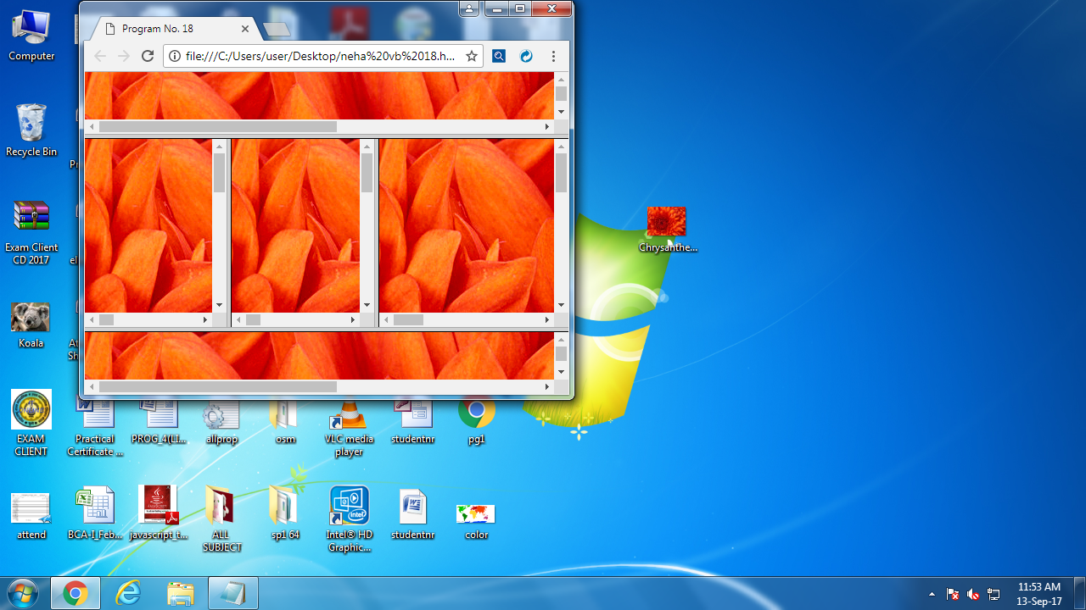

**Practical no. 19**

**Aim:** Write an HTML code to create following table.

**Coding:**

<html>

<head>

<title> Practical 19 <br> Create a Table using html</title>

</head>

<body>

<b></b>

<table border=4 witdh=200 height=170

align=center>

<tr>

<td><b>Make Capacity</b></td>

<td><b> Surya</b></td>

<td><b>Mysore</b></td>

</tr>

<tr>

<td>40W</td>

<td>10.00</td>

<td>10.50</td>

</tr>

<tr>

<td>60W</td>

<td>11.00</td>

<td>11.25</td>

</tr>

<tr>

<td>100W</td>

<td>12.00</td>

<td>12.50</td>

</tr>

</table>

</body>

</html>

**Output:**

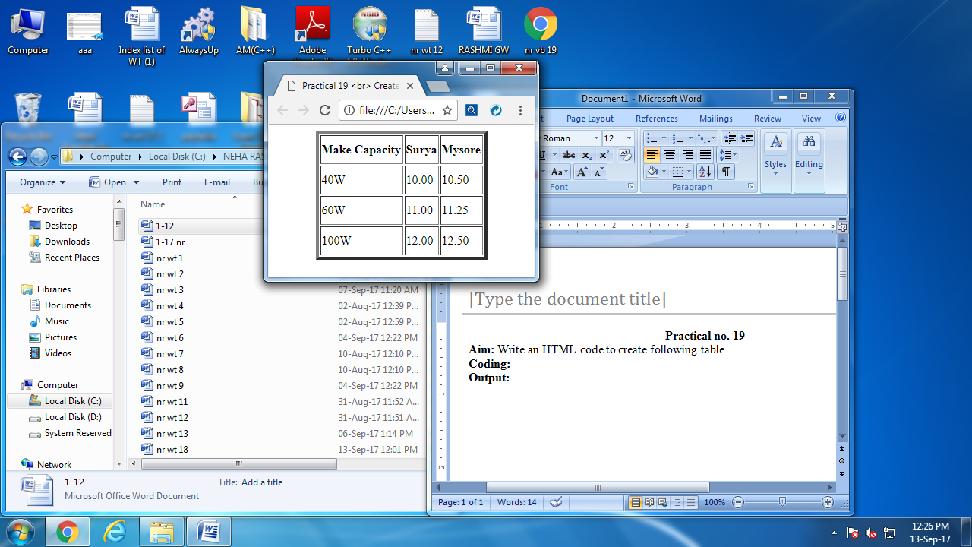

**Practical no. 20**

**Aim:** Write a program in HTML to create login username and password.

**Coding:**

<html>

<head>

<title> program 20 </title>

</head>

<body>

<h1> <b> <font color="black"> Welcome </font></b> </h1>

<hr color= "red">

<center>

<FONT color="black"> Username :<input type="text" Name="Username:" value= " " > <br><br>

<FONT color="black"> Password :<input type="password" Name="Password:" value= ""> <br> <br>

<input type="Button" Onclick="alert ('You are logged in')" Value="log in">

<input type="Button" Onclick="alert ('Cancelled')" Value="Cancel"> <br>

<a href= " ">New Registeration</a>

<a href= " ">Change Password </a>

</body>

</html>

**Output:**

